**ESCHOOL WEBSITE**

**Motivation:**

The current pandemic effected every class of society. Educational sector is one among them. About a whole academic year had been spoilt due to this world pandemic. Many educational institutions are conducting online classes. They are using social media sites like whatsapp. They often be ambiguous as there may arise a confusion to get the right meeting link to get in. Because each day many links will be posted in the groups with lots of people messaging there doubts and their clarification would create a heap of messages which would rather be irritating for people who are already engaged in work from home tensions. There is also a possible side effect of lack of security due to the exposure of mobile numbers in the group chats. This is also very painful for the management to convey right information to the right person.

To address the above difficulties the proposed project will stand a reliable solution and will provide more clear and transparent information exchange. Internet was the only need the user need to have to avail the benefits of the application. This was much affordable when compared to facing all the hectic situations in order to have effective schooling with out interruptions.

**Technology Stack:**

The Project was developed using Spring Framework integrated with Hibernate. For data storage, MySQL 8 database was used. The view pages are developed using JSP .For testing, Junit and mockito are used.The Styling work was done with bootstrap and CSS.

**Project Description:**

The project will contain three logins. They are Admin Login, Teacher Login and Student Login. Each login will redirect to the corresponding home page**.**

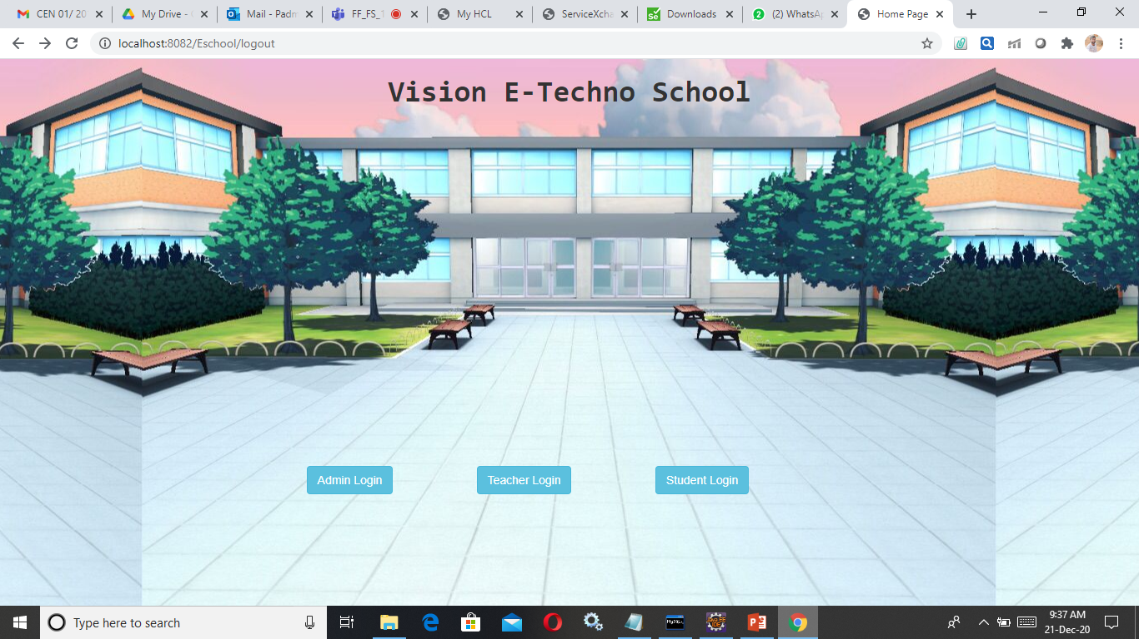

**Admin Module:**

Admins have privileges to add a new teacher and fee details. They can update the status as paid once the due was paid. The admin login present in home page will lead to a admin home page where you will have navigation buttons to go into Add new teacher, update fee and check fee. Once he completed his tasks he can logout from his account. The following screenshots will explain the concept much better.

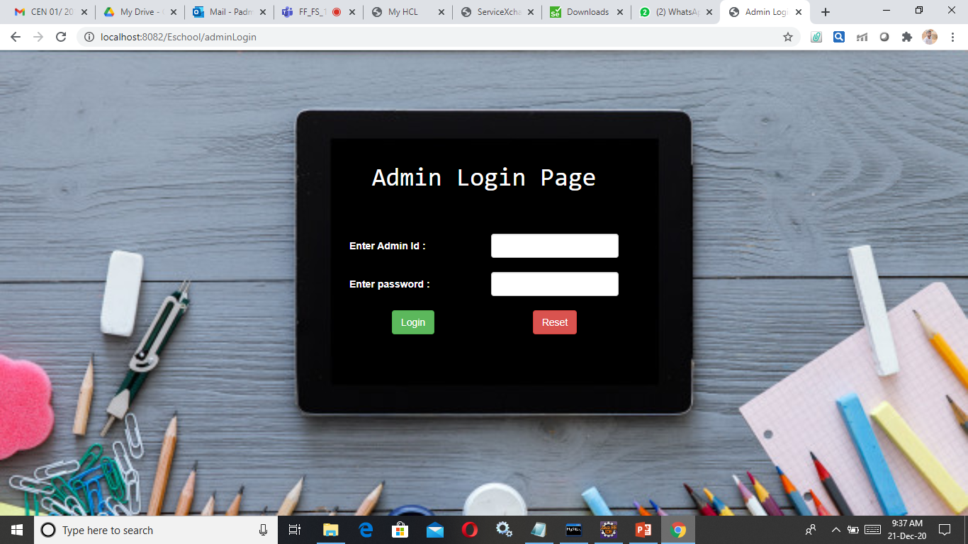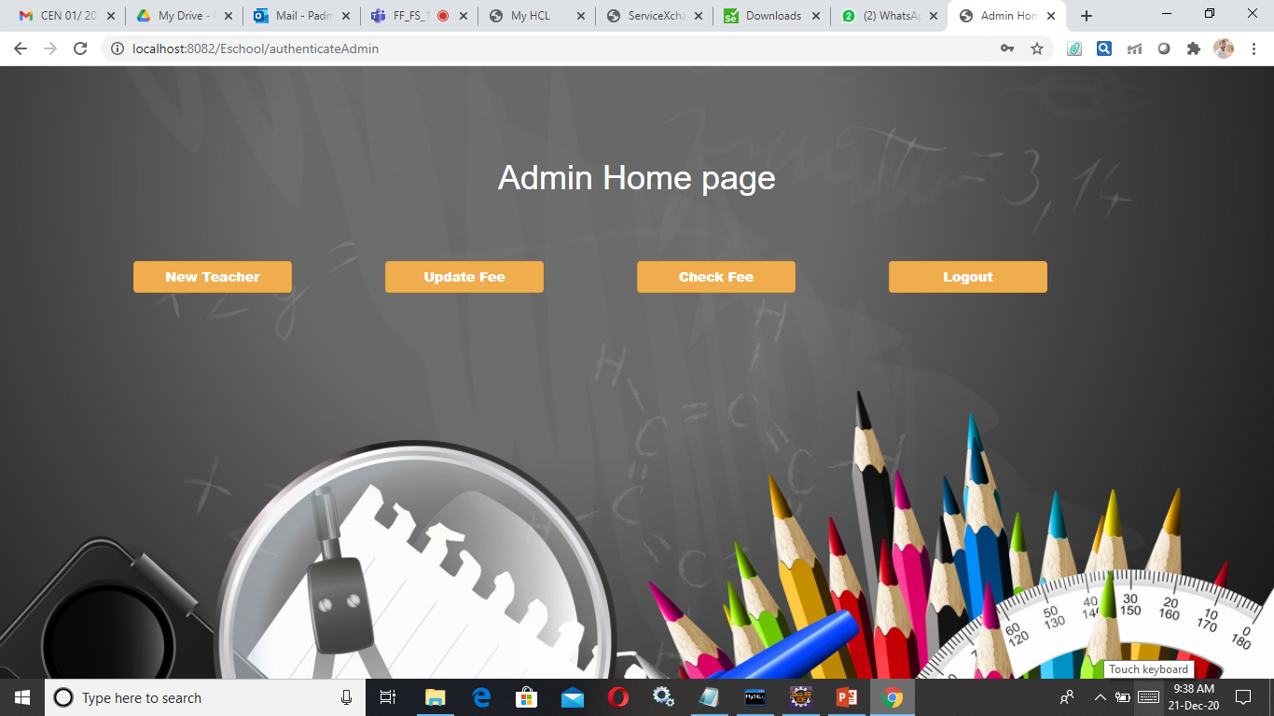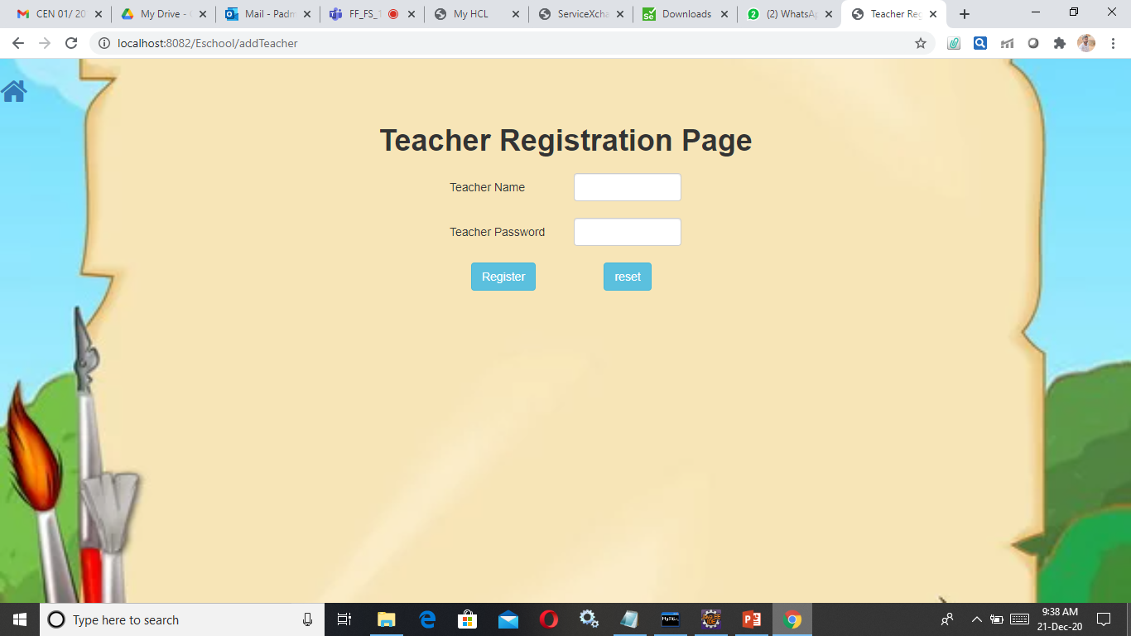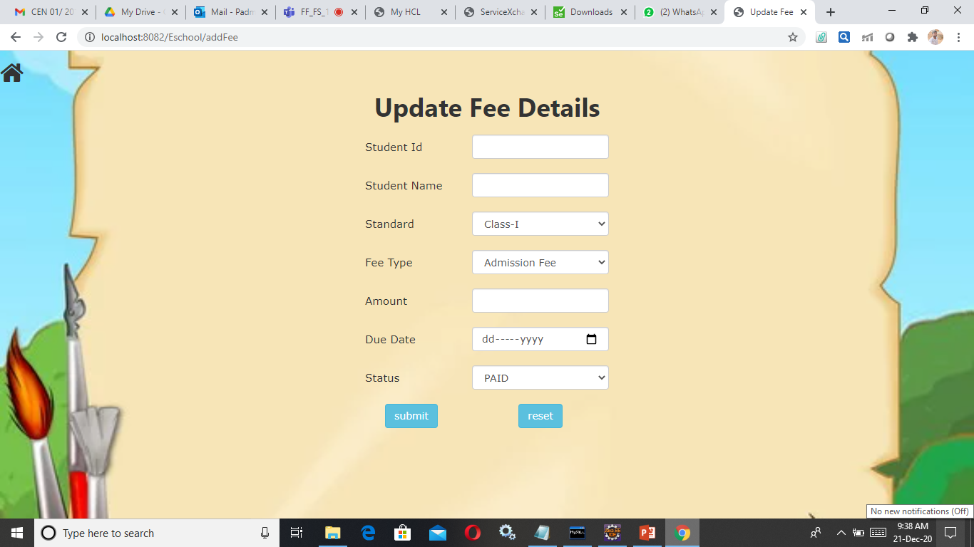

**Teacher Module:**

Teachers can login using teacher login button present on the very first home page. Then they will be directed to a home page called teacher home page. There they will be provided with buttons for adding a new student, adding data into time table, updating enotes, adding a performance feedback for a student.

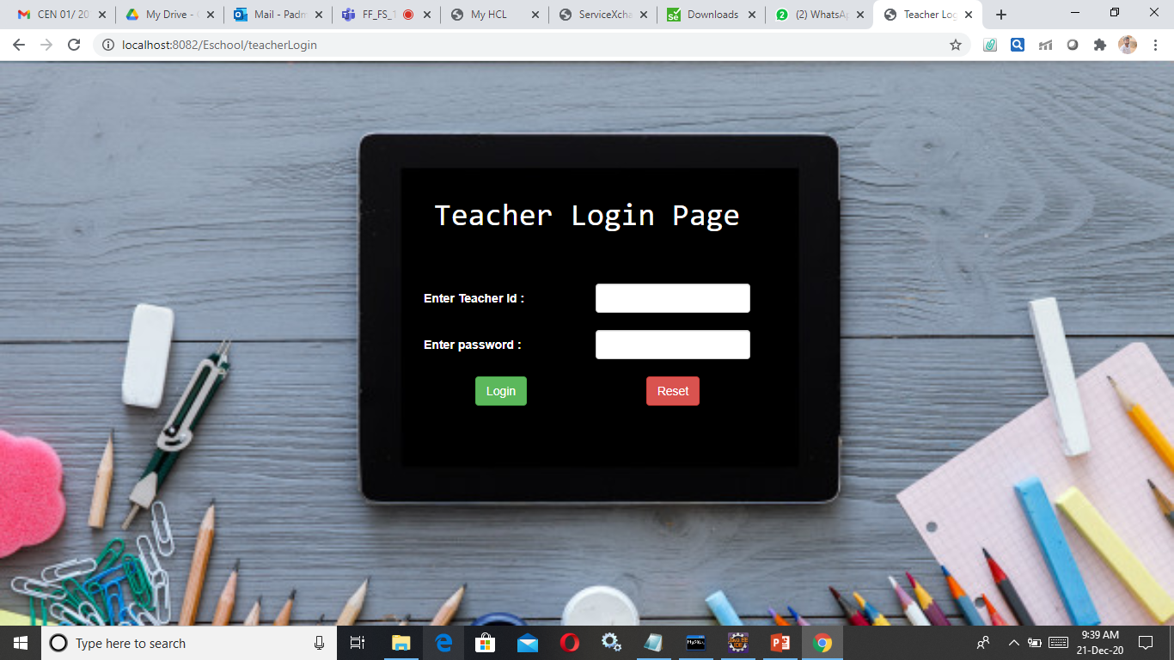

Teachers can even edit or delete any detail by clicking on the edit or delete links provided in corresponding table.

There will a button which will redirect to the feedback given by the student which will help them to enhance their skills. There is also a provision to check the existing timetables, enotes to avoid conflicts while adding new ones.

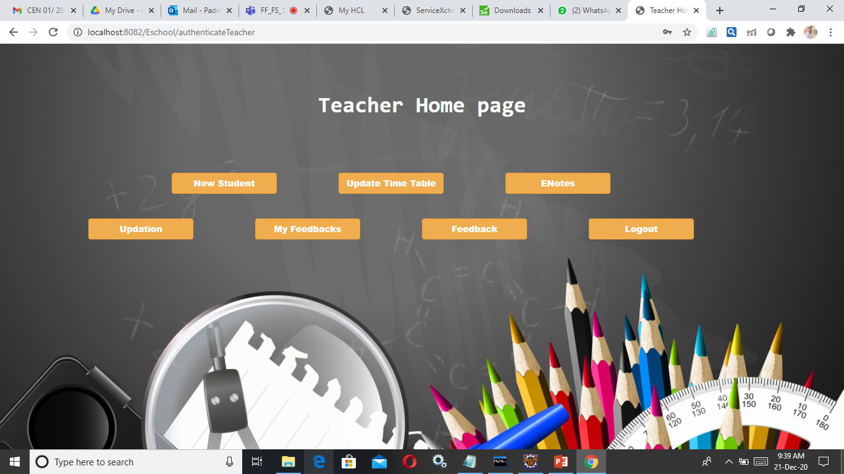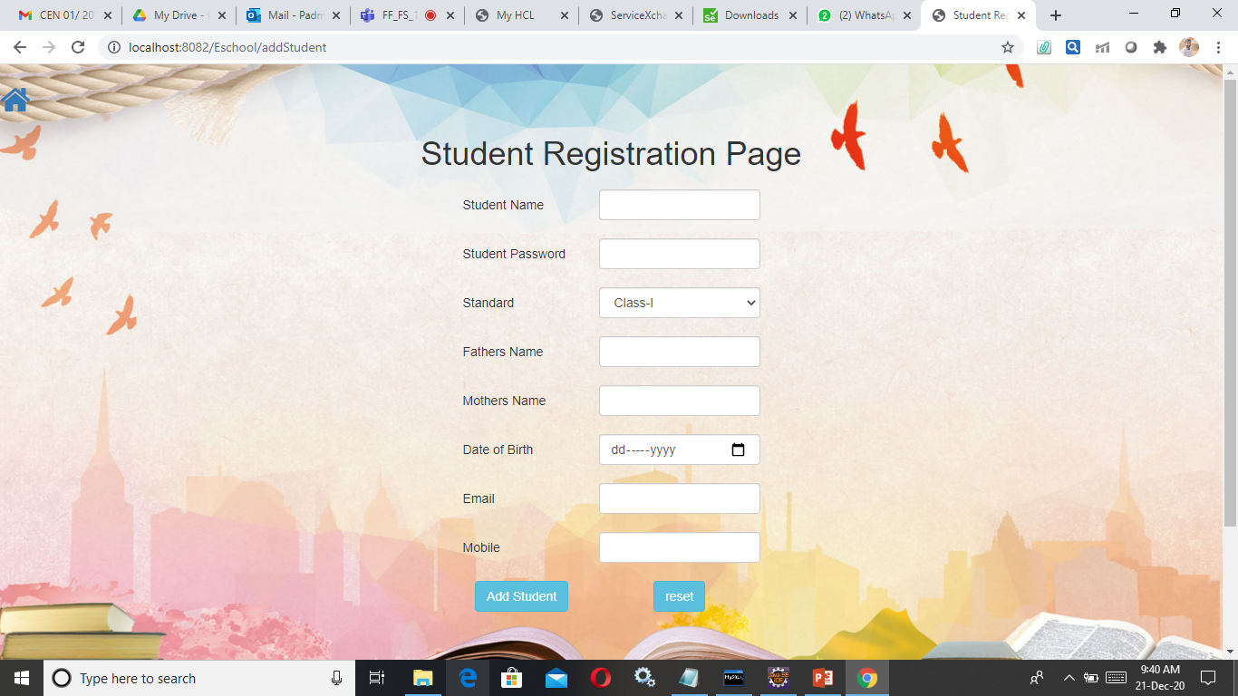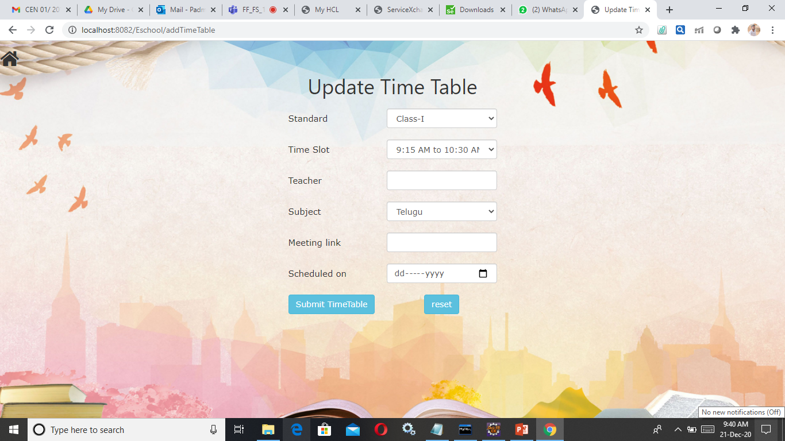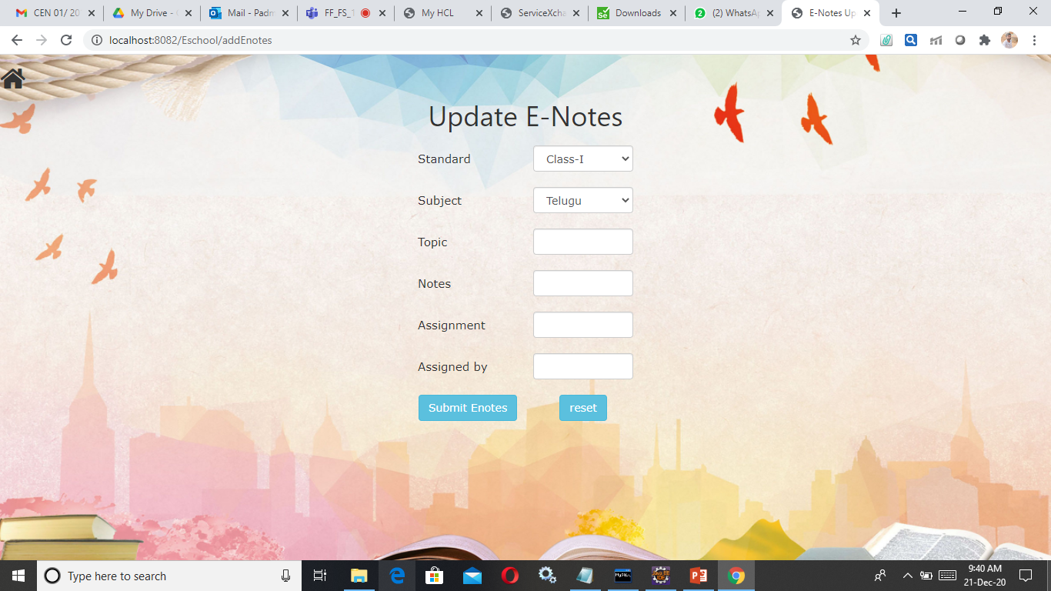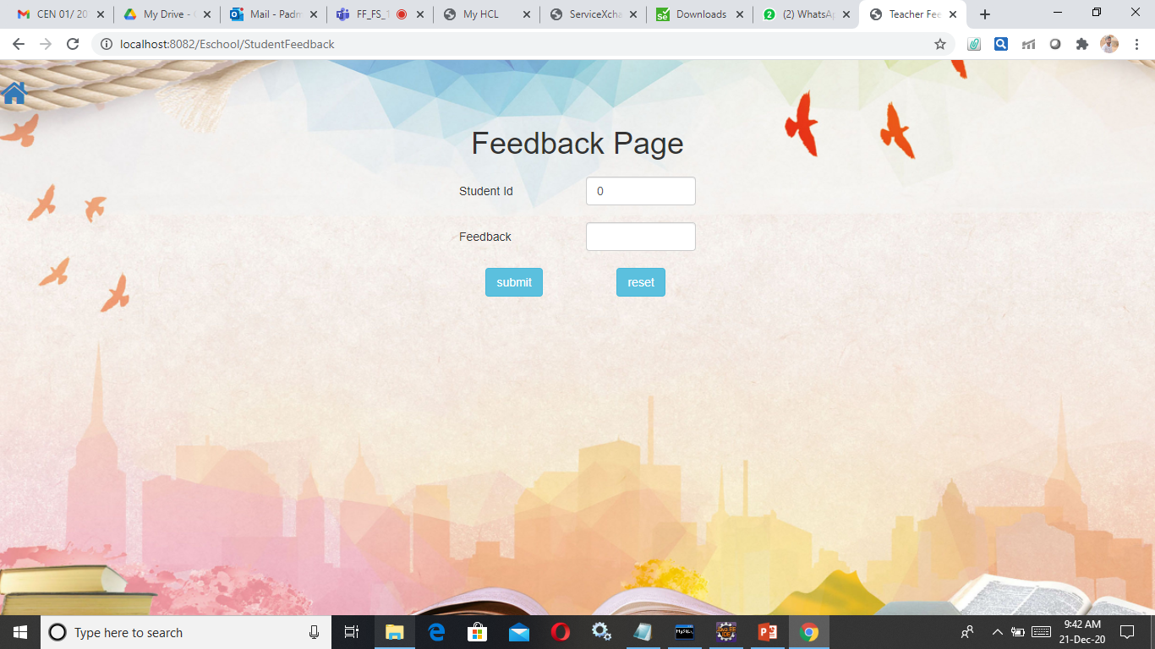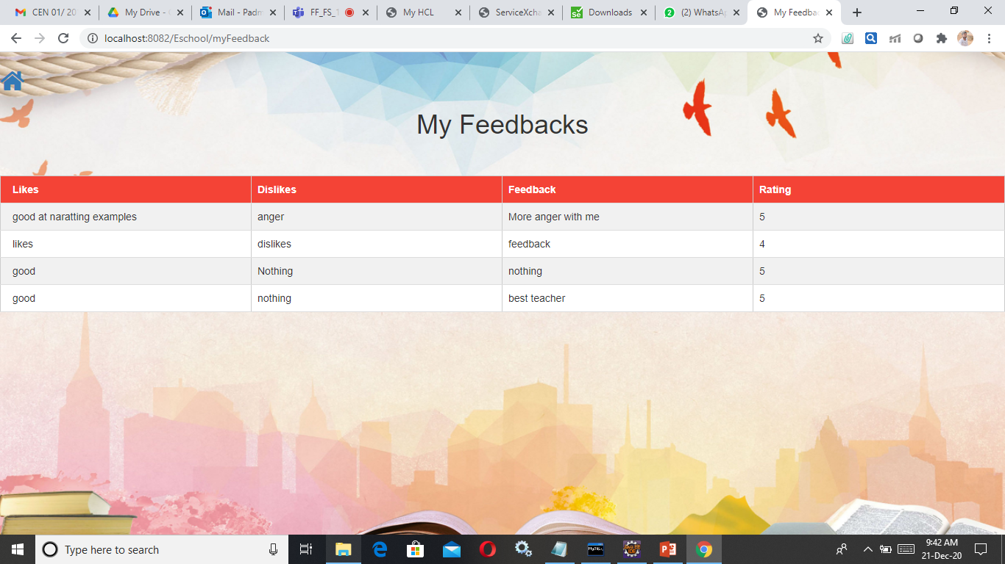

Updation button will redirect you to a standard select page that will allow you to select a standard, So that corresponding standard details can be viewed. Display details will have the buttons to show standard wise timetable, enotes and fee details. Tecaher can finally logout from his account by clicking logout button present in teacher home page.

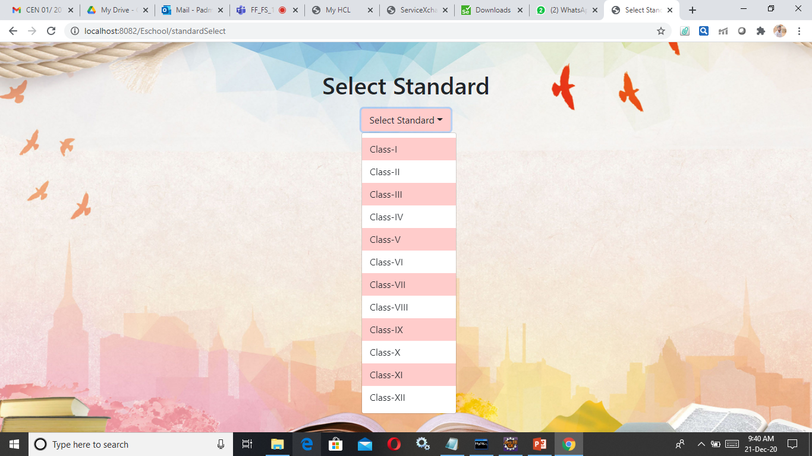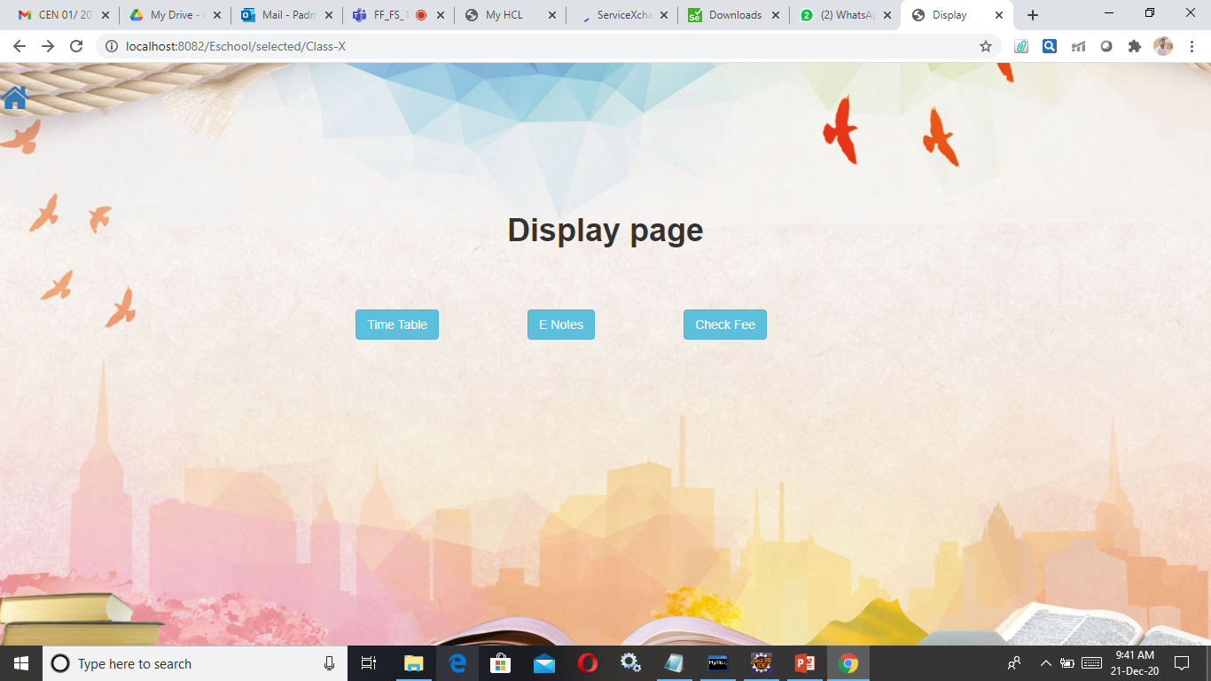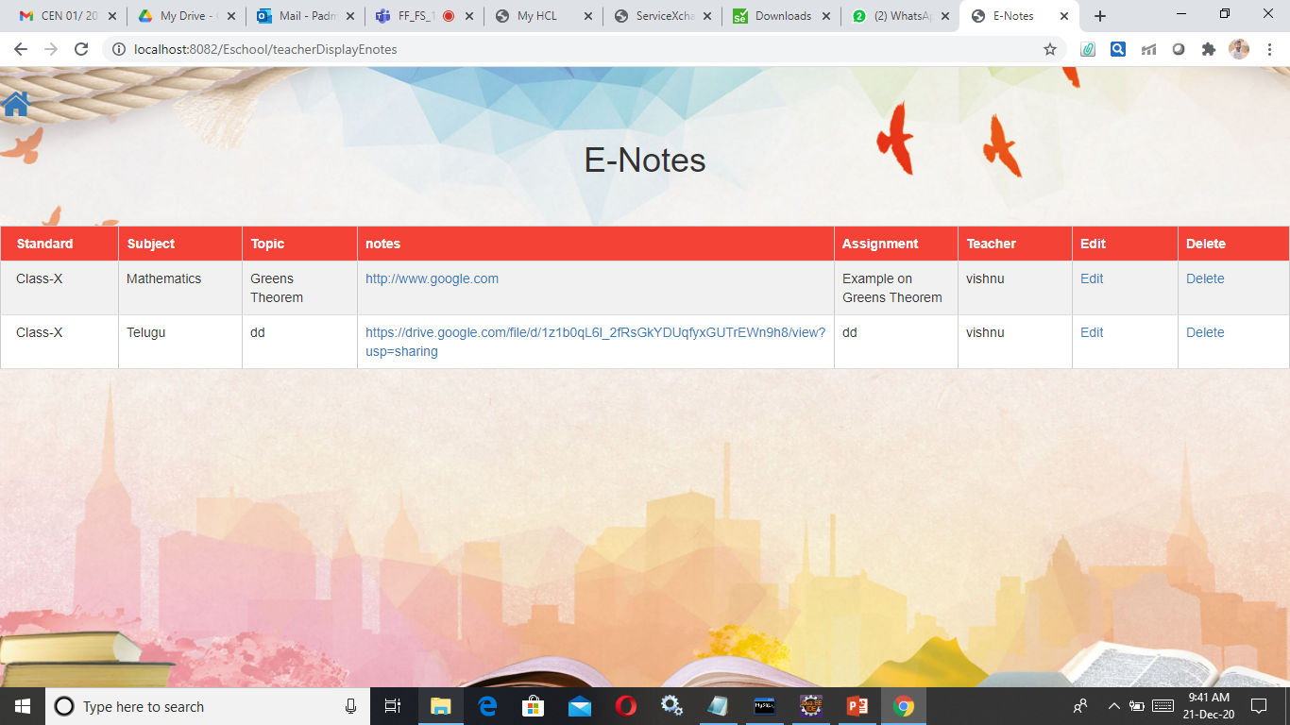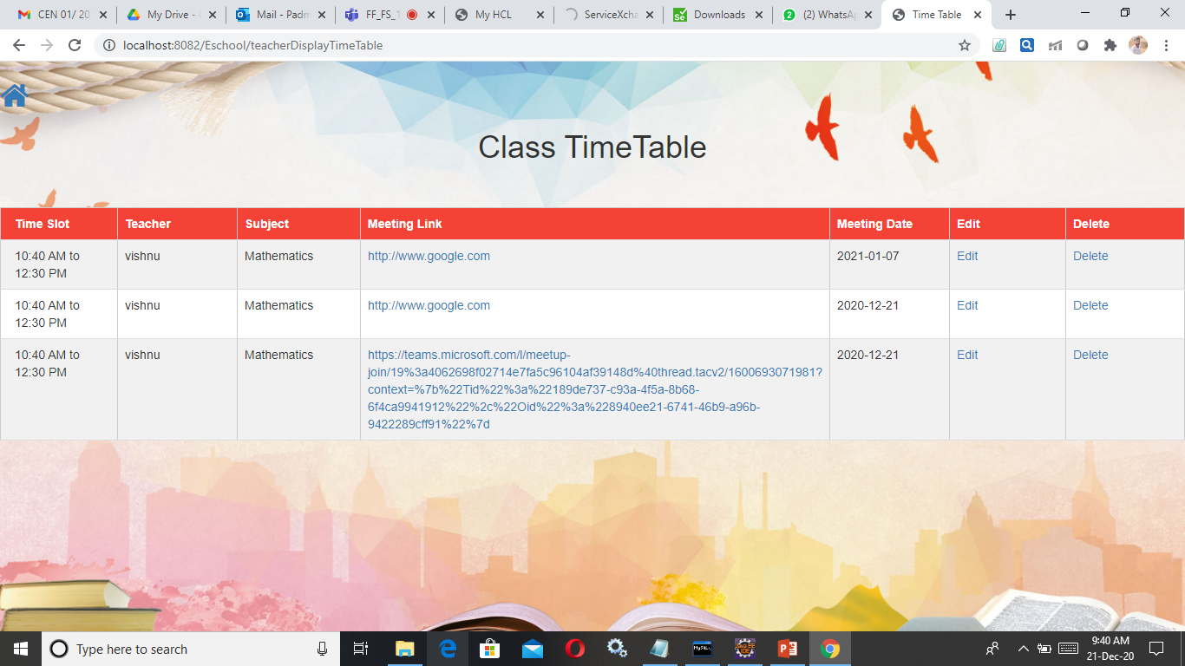

**Student Module:**

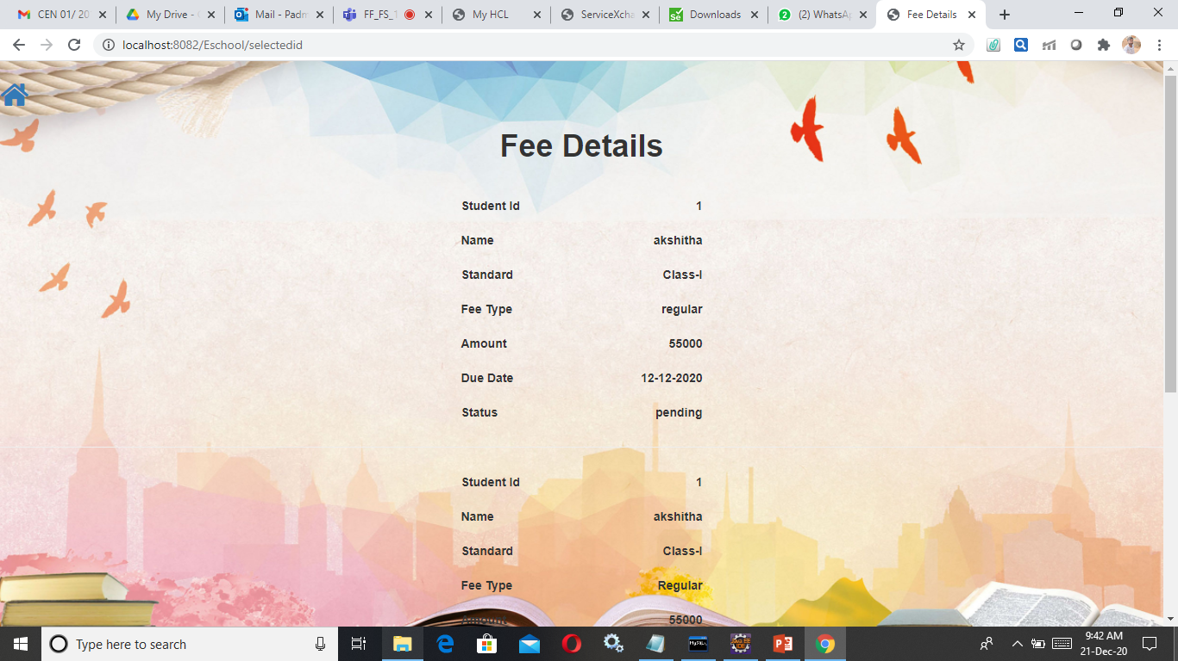

Student will also be given credentials provided by his class teacher. He can get into his account by providing correct credentials. Then he can view the timetable details and enotes details corresponding to his current standard. He can view the timetable, enotes and he can view his personal information by clicking on my details.

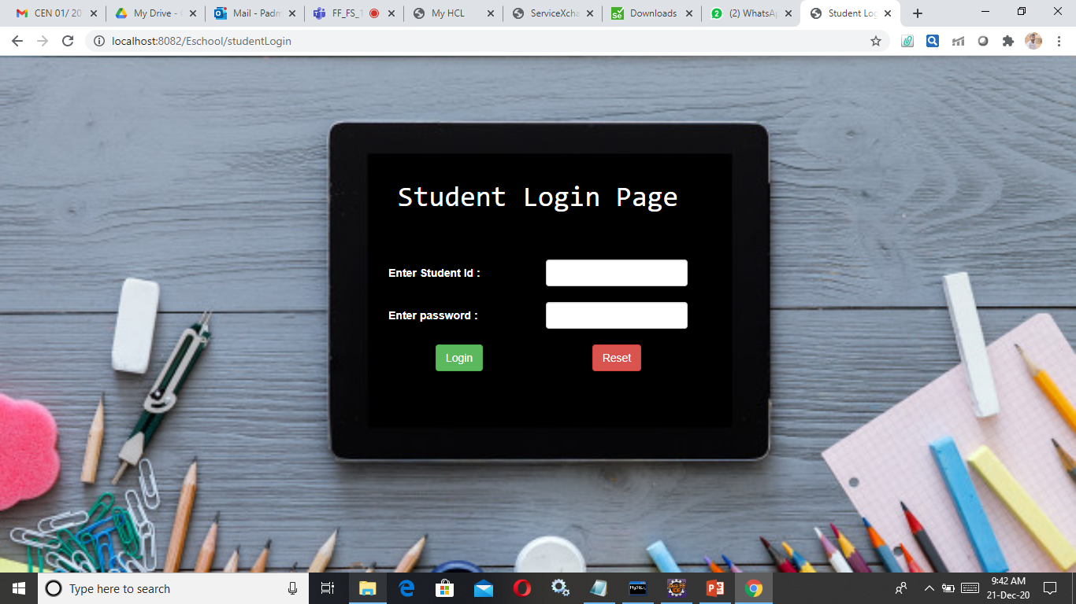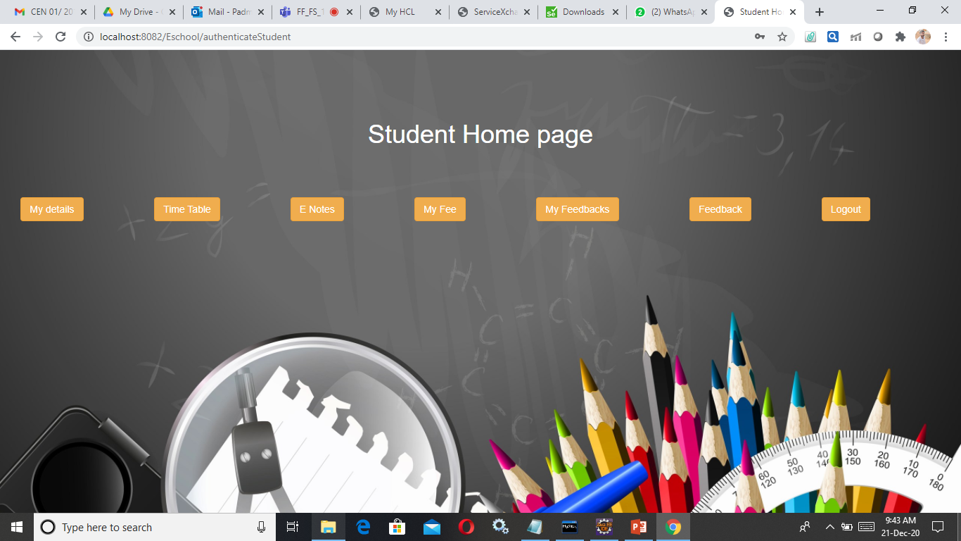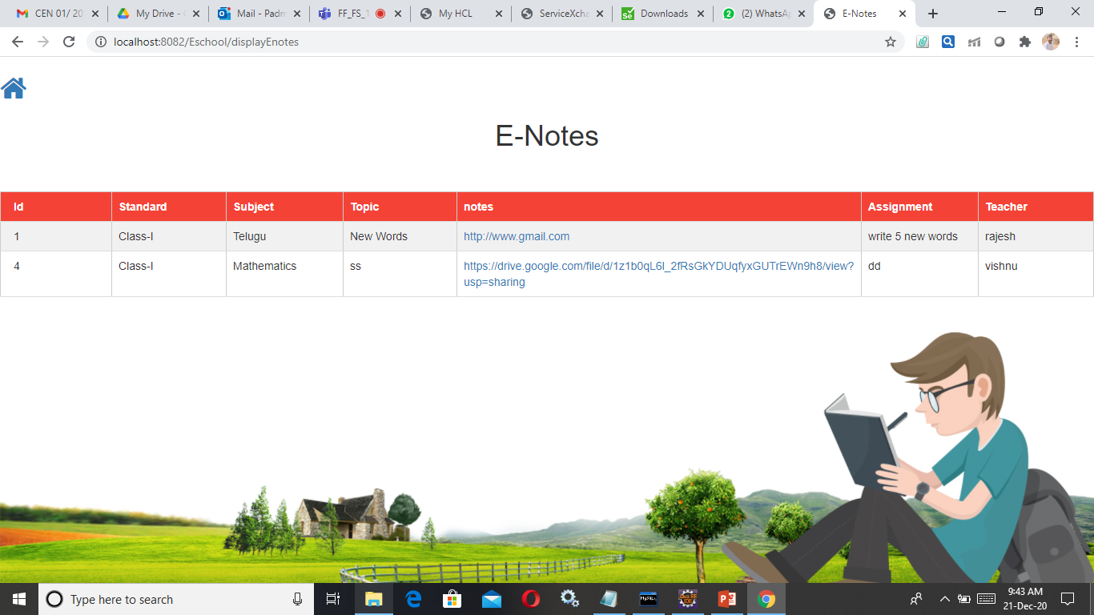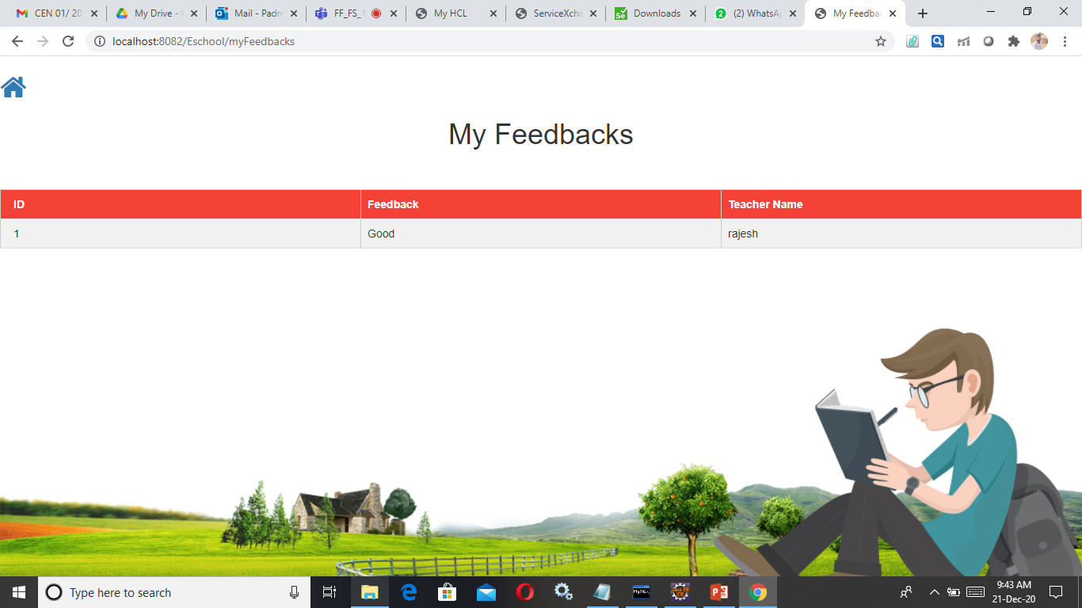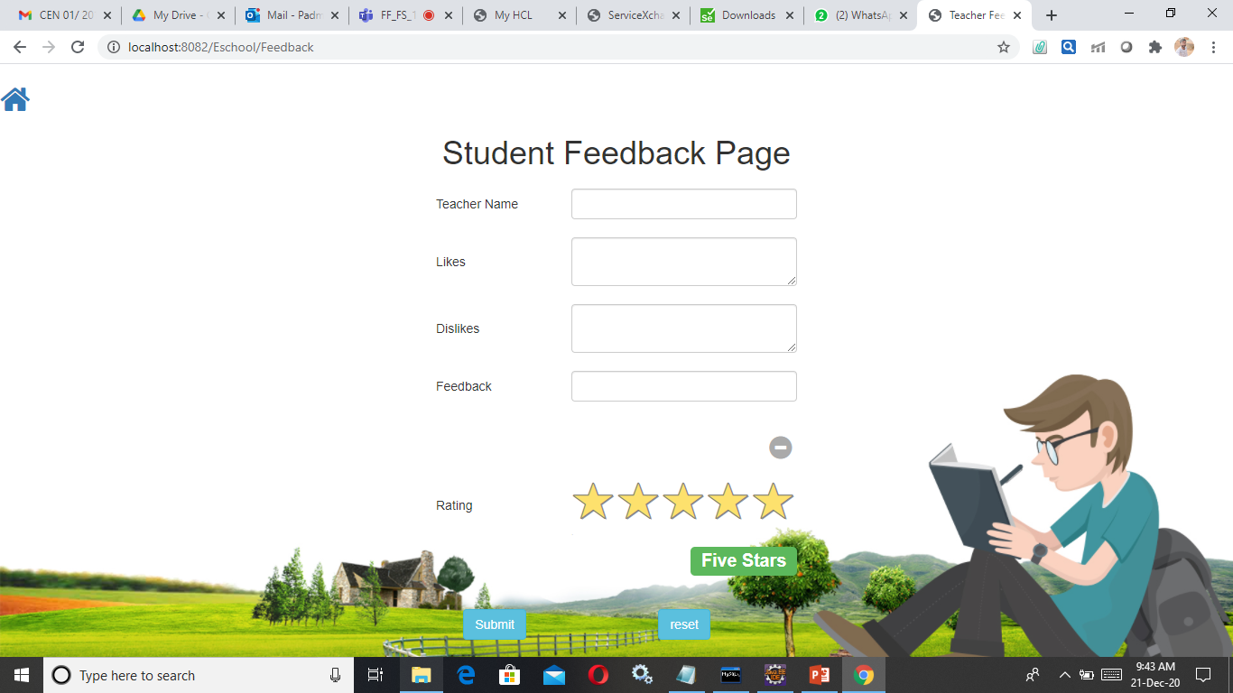

He can give a secret feedback to the teacher about the pros and cons in his teaching. This will help to get more genuine and apt feedbacks.

He also have a button called my feedback to get to know the performance feedback provided by teachers.

**Testing and Logging:**

Testing was done using junit and mockito. The test cases are incorporated in com.src package of src.test.java source folder. Logging was done using log4j.Each method is provided with corresponding logging information to provide better interpretation of work flow of the project.

**Conclusion:**

This would be handy tools to organize data and better accessibility of e-learning stuff for both teachers and student. This application will avoid entering into wrong meeting links and eradicates ambiguity.

The administrator will find a solution to acknowledge the students about fee details.